The Message of the Room
I recently met with Stephen Blair, a long serving principal at Tokoroa North School, to see what he and his staff are doing differently. This school is achieving outcomes that others are not. A decile 3 school in South Waikato with 469 students, not only has a very high percentage of students achieving at or above standard academically, there have been no suspensions, exclusions or stand-downs for the last 16 years. The students are out-performing National and South Waikato results in all areas apart from a very small difference in national reading results. All these things in themselves are stories worth telling. I visited the school looking for the reasons for these great results.
The principal told me that William Glasser’s work on the differences between a Boss Manager and a Lead Manager had been a significant influence on his whole way of being, in the school. A Lead Manager works on continually improving relationships within the school or workplace. A Lead Manager uses non-coercive practices, where maintaining relationships are paramount. It is about being a Lead Manager rather than doing Lead Management.
In visiting this school, I witnessed a good example of a school in which Glasser’s Lead Management principles are being implemented. This has created the conditions for a school to not only build constructive social relationships but also to achieve excellent academic results as measured by the National Standards.
The principal of Tokoroa North School stated that “If the adult relationships are not right in the school amongst teaching staff, then the relationships between teacher and children and children and children will suffer.”
He believes that people watch him intently (as principal) to see that he models what he believes in - all the time. He says that it is about modelling the behaviour you want to see in your school.
Our western society is deeply ingrained in crime and punishment and it is easy to fall back on that approach when things get difficult. It is not a case of moving to Boss Management to suit yourself as good relationships can quickly be destroyed.
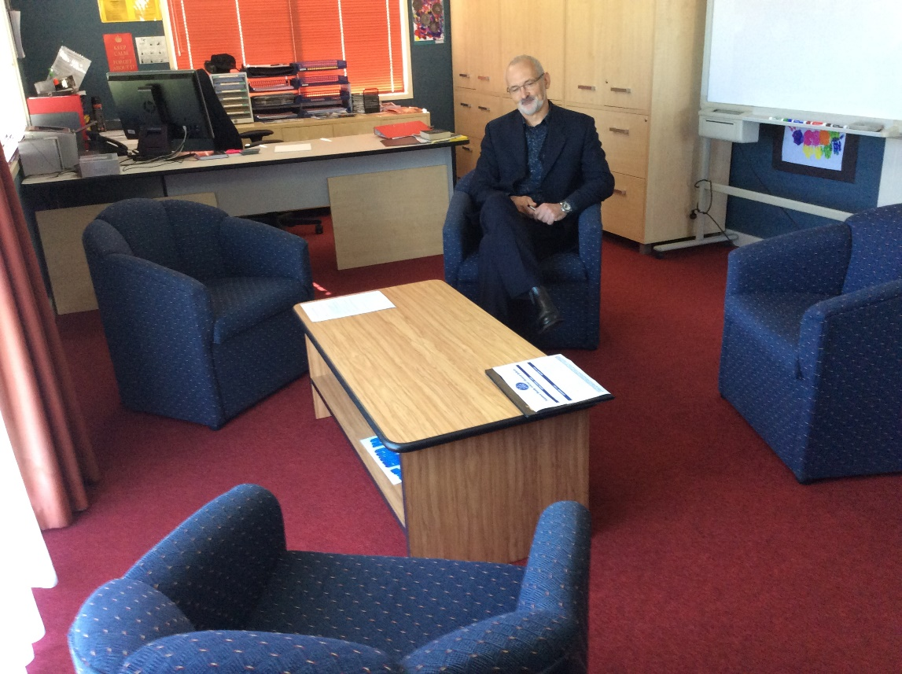
The message of the room for me when I entered Stephen’s office was one of collaboration and team work. The arrangement of his office spoke volumes as it modelled a place where all ideas were valued and could be shared in a relaxed and open way. The comfortable chairs were around a large low table as opposed to a work table. To me this demonstrated the shared beliefs of the school in building trust, sharing decision making and using a non-coercive management style.
Choice was also a feature for staff in the school. Learning about the work of the Brazilian Ricardo Semler early in his career, the principal recognised the alignment Semler’s work had with Glasser’s Choice Theory. Staff meetings at Tokoroa North are not compulsory. Believing in personal responsibility, Stephen trusts that people will make choices about attendance and that they will be accountable for finding out the information if they choose not to go to the meetings.
The school has been involved in significant training in William Glasser’s Choice Theory and Lead Management both from visiting consultants and from respected staff within the school. The evidence of the application of the internal control psychology concepts of non-coercion, self-management and the pursuit of quality work that was learnt in this training, is seen in the work of members of staff; the principal, the teachers, the students and parents. This school is truly a great example of what Choice Theory and Lead Management in action can achieve.
Please contact Bette Blance on bette@choiceconnections.nz for further information.

